XC4614 flash reprogramming with XC4464 or XC4414
The XC4614 has its own internal storage which can be reprogrammed to give different functions. As delivered, the XC4614 has the transparent wifi-serial firmware with webpage configuration installed. The AT-command firmware can also be installed, giving more access to low level functions.
There’s a couple of different firmware versions (including a 9600 baud AT command firmware) in this folder, but more can be found at places like:
https://shm-forum.org.uk/t/list-of-esp8266-firmware/98

Wiring it up:

To XC4464:
You will need WC6028 (plug to socket jumpers). Ensure that the voltage switch on the XC4464 is set to 3V3, as the ESP13 chip is only rated to 3.3V. Make the following connections:

XC4614 (Wifi Shield) | XC4464 (FTDI Board) | Function
5V (on Arduino side) | 5V | Power (there is a 3.3V regulator on the board)
G (on Arduino side) | GND | Ground
RX0 (on ESP13 side) | TXD | Data from XC4614
TX0 (on ESP13 side) | RXD | Data to XC4614
D0 (on ESP13 side) | No connection | Programming selector- goes to G on XC4614

During the programming phase, the wire on D0 is connected to GND (G) on the shield (see green wire in picture above). This tells the shield to enter programming mode next time it is reset.
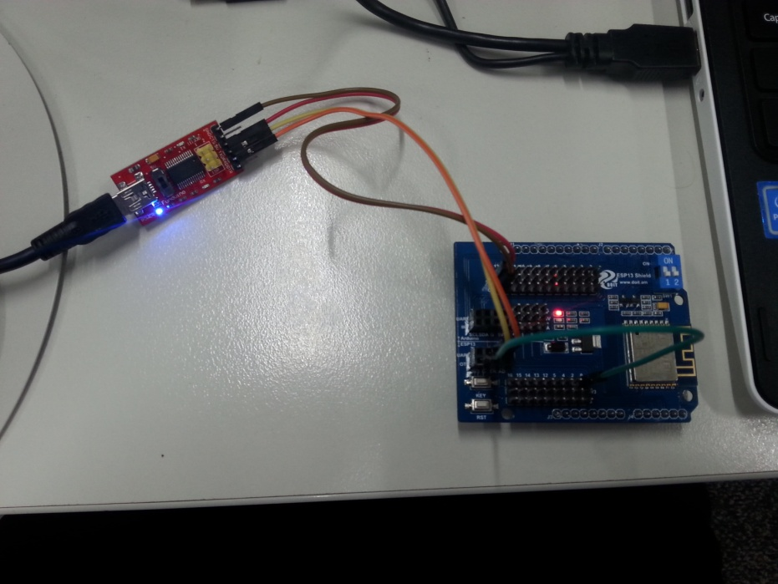

To Nano (XC4414):
If you’re using a Nano, make sure it has a sketch that doesn’t use the Serial port at all (the easiest way is to select File>New, and upload the empty sketch to the board). We’re just using the USB-Serial converter on the board, so the sketch doesn’t need to do anything.
XC4614 (Wifi Shield) | XC4414 (Nano) | Function
5V (on Arduino side) | 5V | Power (there is a 3.3V regulator on the board)
G (on Arduino side) | GND | Ground
RX (on Arduino side) | TX1 | Data from Nano board
TX (on Arduino side) | RX0 | Data to Nano board
D0 (on ESP13 side) | No connection | Programming selector- goes to G on XC4614

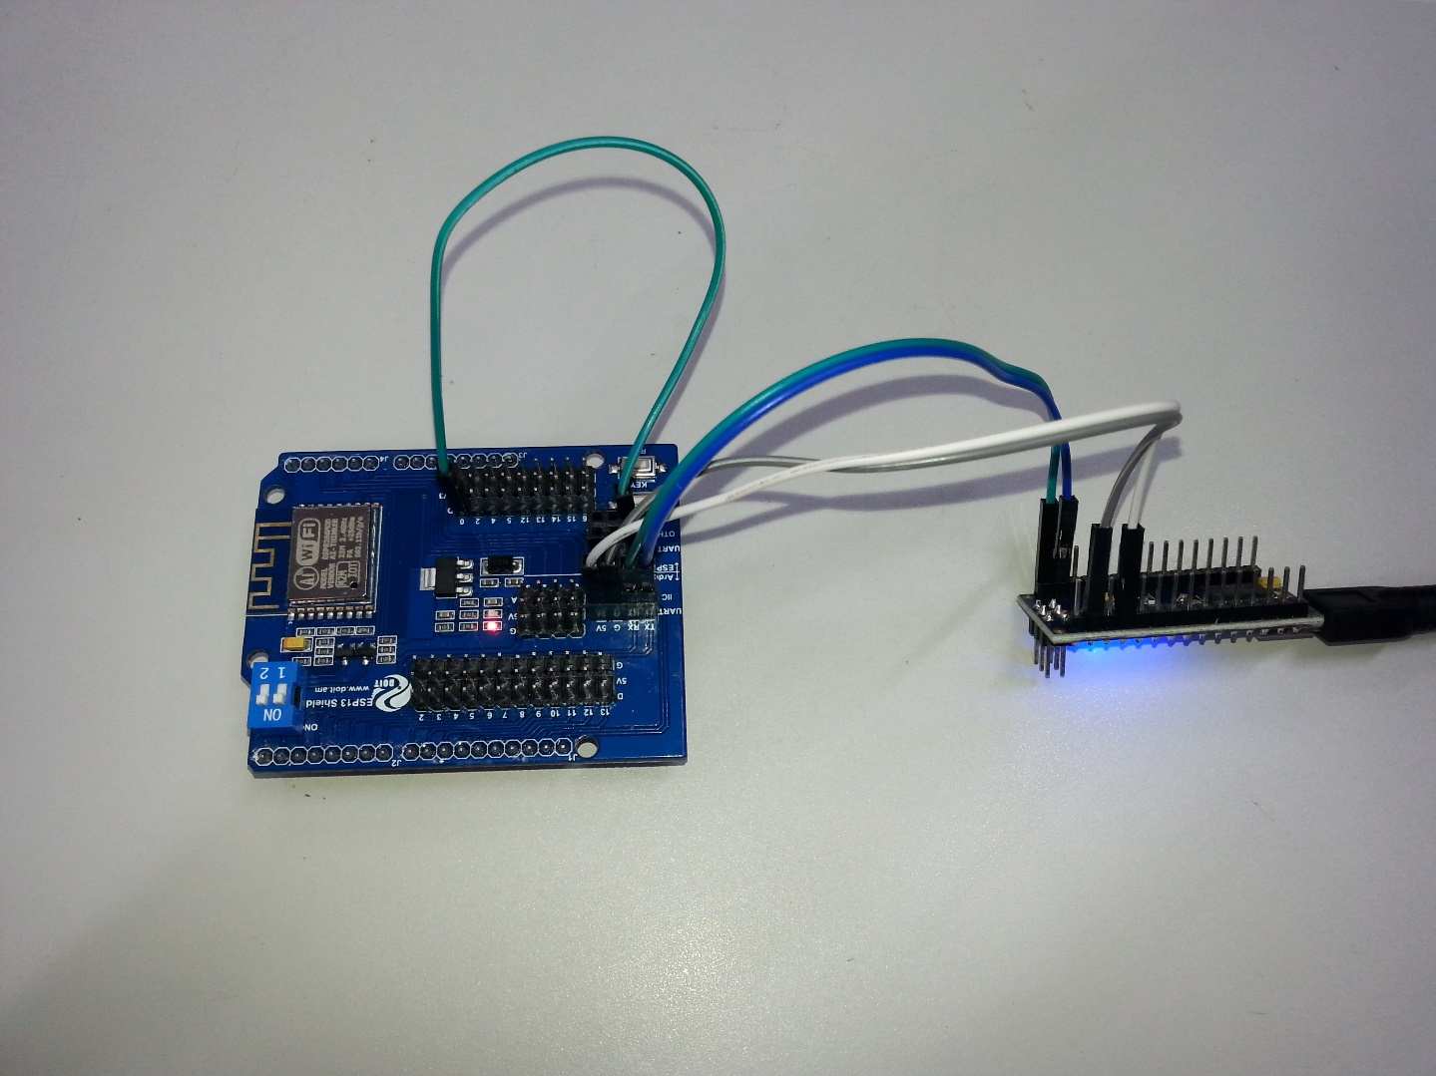
During the programming phase, the wire on D0 is connected to GND (G) on the shield (see green wire in picture above). This tells the shield to enter programming mode next time it is reset.

Flashing the firmware:
Open the ESP8266Flasher program, and click on the Config tab, then click on the second gear icon and select the .bin file you wish to upload. Make sure the address at right is set to 0x00000.
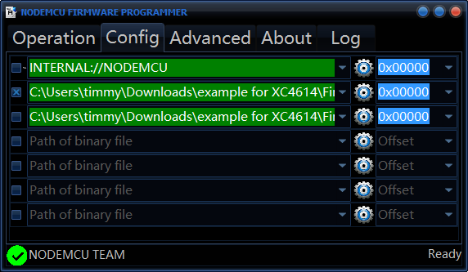

Click on the Operation tab. Make sure that the COM Port is the right one for the XC4464, connect the D0 wire to G, press RST on the shield and then click Flash.
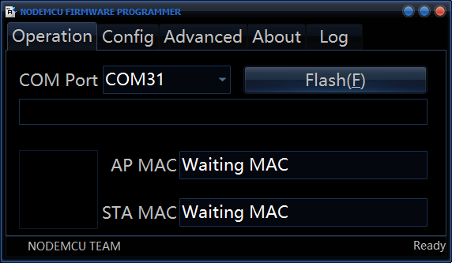
After a few seconds the blue progress bar should start moving. If it doesn’t, and the message ‘need gpio’ appears, check that the green wire is connected between D0 and GND, and press RST. Once the flashing is complete, the screen will appear as below. The two MAC addresses may be different.
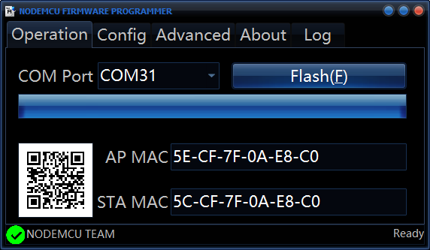
The board is now reflashed with the new firmware. If you want to try programming the shield as though it was a standalone Arduino Board, you can use the same wiring.

